SPARQL Query Tasks Report

# Introduction

The SPARQL Protocol and RDF Query Language (SPARQL) is a powerful and versatile query language used to retrieve and manipulate data stored in Resource Description Framework (RDF) format. It is a standard query language for databases, able to retrieve and manipulate data stored in RDF format, which is widely used in semantic web and linked data projects.  
  
Wikidata is a collaboratively edited knowledge base hosted by the Wikimedia Foundation. It serves as a common source of structured data for Wikimedia projects such as Wikipedia, and for everyone on the web. The data stored in Wikidata is accessible through a variety of interfaces, including a SPARQL endpoint, which allows users to query the data using the SPARQL query language.  
  
This report aims to construct and execute SPARQL queries to extract specific information from the Wikidata knowledge graph and present the results in a clear and informative manner.

# Task 1: Fountains in Rome

## Step-by-Step Query Construction

To construct the SPARQL query for listing the names of fountains in Rome documented on Wikidata, along with their geographical coordinates and images, the following steps were followed:  
  
1. Select Variables: The query needs to select the fountain's name, coordinates, and image.  
 - ?fountain: Represents the fountain entity.  
 - ?fountainLabel: Represents the name of the fountain.  
 - ?coordinates: Represents the geographical coordinates of the fountain.  
 - ?image: Represents the image of the fountain.  
  
2. Define the Entity Type and Location: The query needs to filter entities that are fountains located in Rome. The IDs can be found by looking for the entities in Wikidata or with the query assistant.

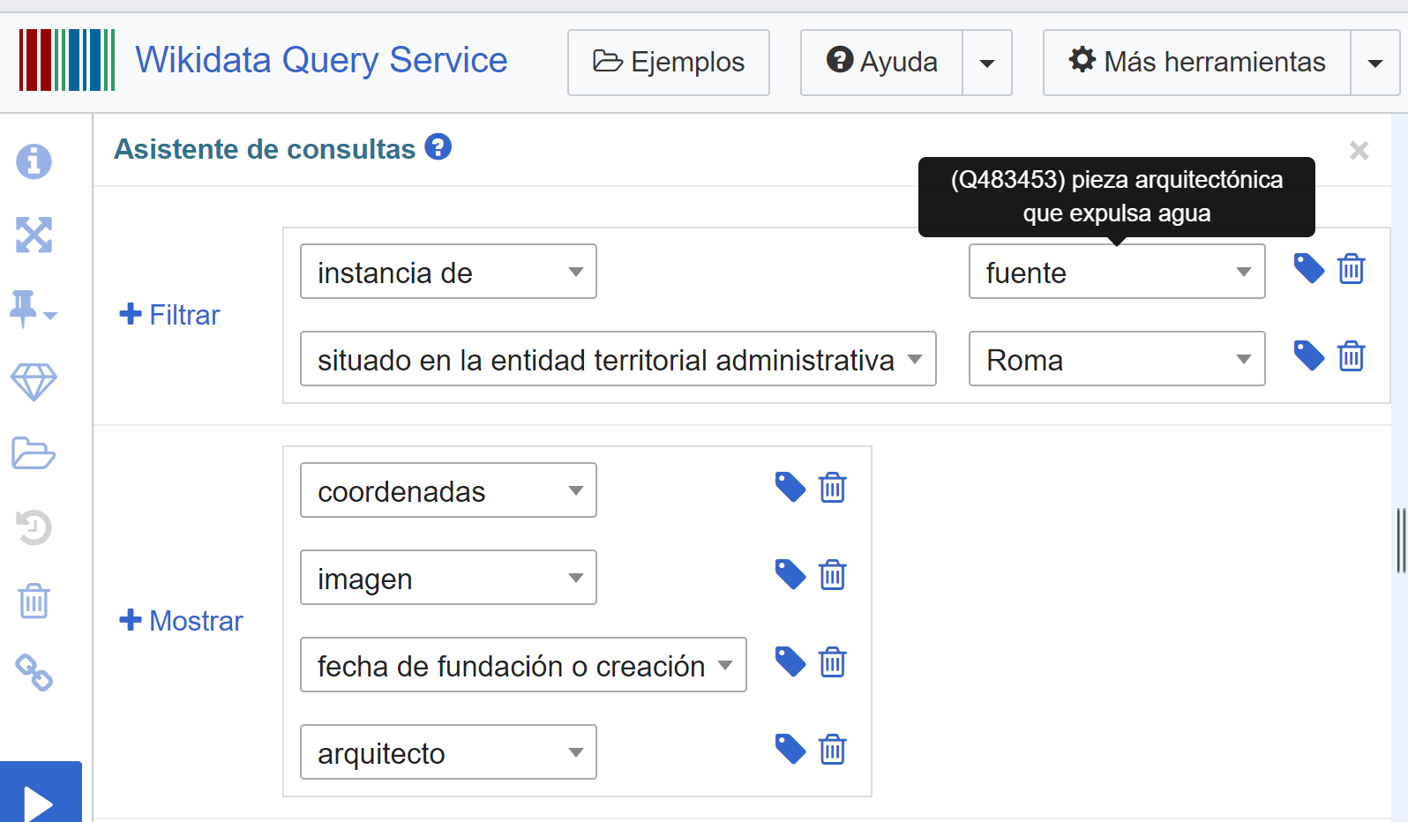

- Using wd:Q483453: The Wikidata entity for a fountain.  
 - Using wd:Q220: The Wikidata entity for Rome.  
  
3. Include Language Filter: The names should be in Italian.  
 - Adding a language filter for ?fountainLabel to ensure names are in Italian.  
  
4. Construct the Query:  
  
SELECT ?fountain ?fountainLabel ?coordinates ?image WHERE {  
 ?fountain wdt:P31 wd:Q483453.  
 ?fountain wdt:P131 wd:Q220.  
 ?fountain wdt:P625 ?coordinates.  
 OPTIONAL { ?fountain wdt:P18 ?image. }  
 SERVICE wikibase:label { bd:serviceParam wikibase:language "it". }  
}

Parts of the query:

1. **SELECT ?fountain ?fountainLabel ?coordinates ?image**: Specifies the variables to be returned in the results.
2. **WHERE { ... }**: Defines the pattern to match in the graph.

* **?fountain wdt:P31 wd:Q483453**: Matches entities that are instances of the class "fountain" (Q483453).
* **?fountain wdt:P131 wd:Q220**: Matches entities that are located in Rome (Q220).
* **?fountain wdt:P625 ?coordinates**: Matches the geographical coordinates of the fountain.

1. **OPTIONAL { ?fountain wdt:P18 ?image }**: Optionally matches the image of the fountain, if available.
2. **SERVICE wikibase:label { bd:serviceParam wikibase:language "it" }:** Ensures that labels are returned in Italian.

## Results

The query returned a list of 42 fountains in Rome in 1571 ms with their names in Italian, geographical coordinates, and images (where available). Below are some examples from the query results:  
  
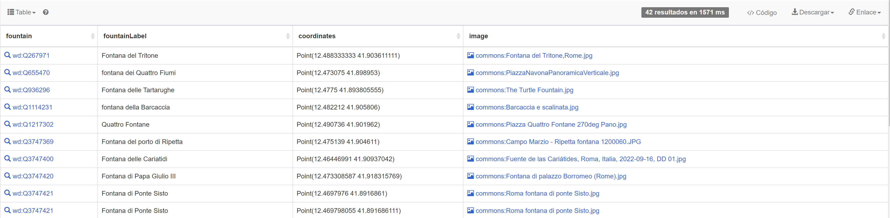

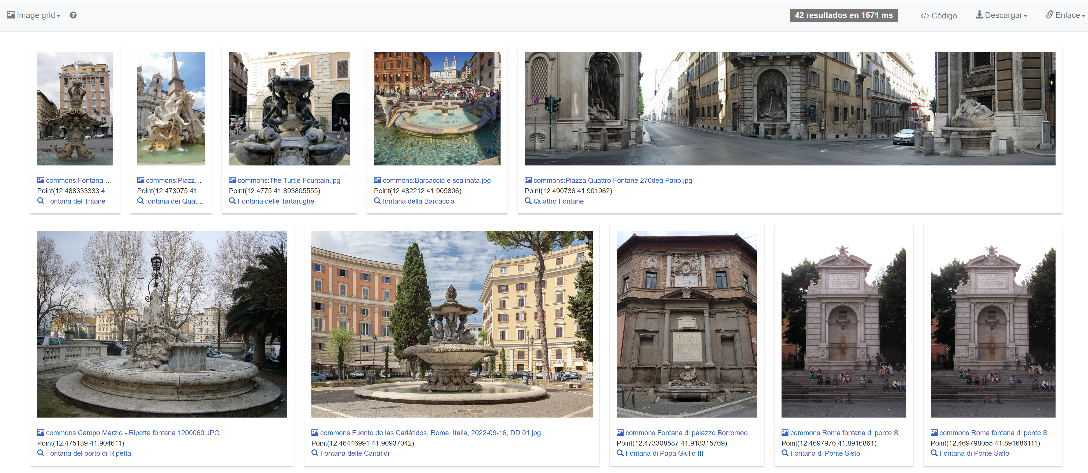

The geographical coordinates obtained from the query were plotted on a map of Rome using the Map View.

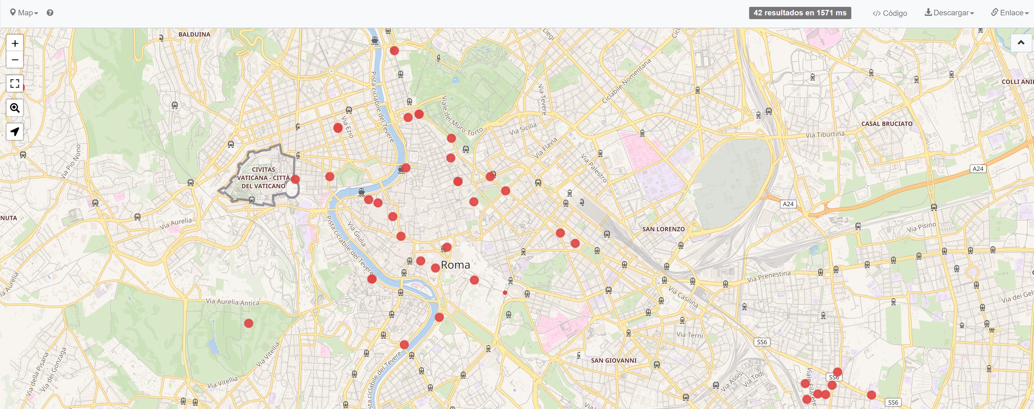

## Additional Experiments

To enhance the analysis, additional experiments were conducted:  
- Extracting more details about each fountain, such as the year of construction and the architect.

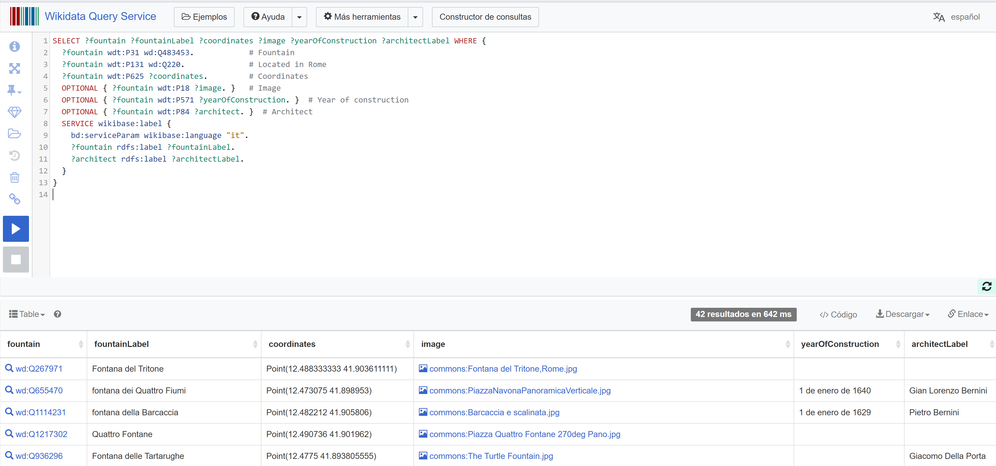

* **OPTIONAL { ?fountain wdt:P571 ?yearOfConstruction. }**: This part of the query retrieves the year of construction of the fountain if the information is available.
* **wdt:P571**: Property for "inception" or year of construction.
* **OPTIONAL { ?fountain wdt:P84 ?architect. }**: This part of the query retrieves the architect of the fountain if the information is available.
* **wdt:P84**: Property for "architect".
* **?architectLabel**: The label (name) of the architect in Italian.

# Conclusion

The SPARQL query successfully retrieved detailed information about fountains in Rome, including their names in Italian, geographical coordinates, and images. The results were visualized on a map to provide a clear representation of their locations. Additional experiments provided further insights about who designed them and when.  
  
This report demonstrates the power of SPARQL in extracting and analyzing structured data from the Wikidata knowledge graph, showcasing its potential for various applications in data analysis and research.

# Task 2: Australian Archbishops

## Step-by-Step Query Construction

To construct the SPARQL query for listing the names of Australian archbishops documented in DBpedia, sorted by their birth date, the following steps were followed:  
  
1. Select Variables: The query needs to select the archbishop's name and birth date.  
 - ?archbishop: Represents the archbishop entity.  
 - ?name: Represents the name of the archbishop.  
 - ?birthDate: Represents the birth date of the archbishop.  
  
2. Define the Entity Type and Nationality: The query needs to filter entities that are archbishops and are Australian.  
 - Using dbo:Archbishop: The DBpedia ontology class for archbishops.  
 - Using dbo:birthPlace: The property to filter Australian nationality.  
 - Using dbr:Australia: The DBpedia entity for Australia.  
  
3. Sort the Results: The query results should be sorted by birth date from the most modern to the oldest.  
  
4. Construct the Query:  
  
SELECT ?archbishop ?name ?birthDate WHERE {  
 ?archbishop a dbo:Archbishop .  
 ?archbishop dbo:birthPlace dbr:Australia .  
 ?archbishop foaf:name ?name .  
 ?archbishop dbo:birthDate ?birthDate .  
} ORDER BY DESC(?birthDate)

Parts of the query:

1. **SELECT ?archbishop ?name ?birthDate**: Specifies the variables to be returned in the results.
2. **WHERE { ... }**: Defines the pattern to match in the graph.

* **?archbishop a dbo:Archbishop**: Matches entities that are instances of the class "Archbishop".
* **?archbishop dbo:birthPlace dbr:Australia**: Matches entities whose birthplace is Australia.
* **?archbishop foaf:name ?name**: Matches the name of the archbishop.
* **?archbishop dbo:birthDate ?birthDate**: Matches the birth date of the archbishop.

1. **ORDER BY DESC(?birthDate)**: Sorts the results by birth date in descending order, from the most modern to the oldest.

## Running the Query

The query was executed using the DBpedia SPARQL endpoint at https://dbpedia.org/sparql. The endpoint provides various output formats including Table and CSV, which are useful for analyzing the data.

## Results

The query returned a list of Australian archbishops with their names in English and birth dates, sorted from the most modern to the oldest. Below are some examples from the query results in HTML, Turtle and CSV format. This provides a lot of flexibility for its integration in different tools.

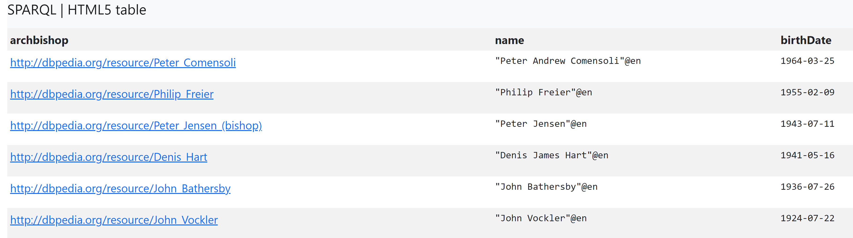  
  
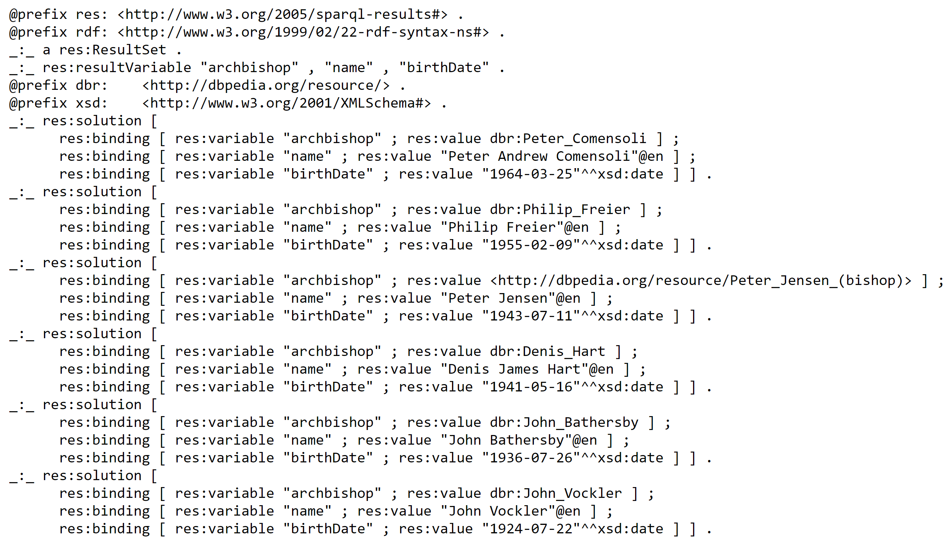

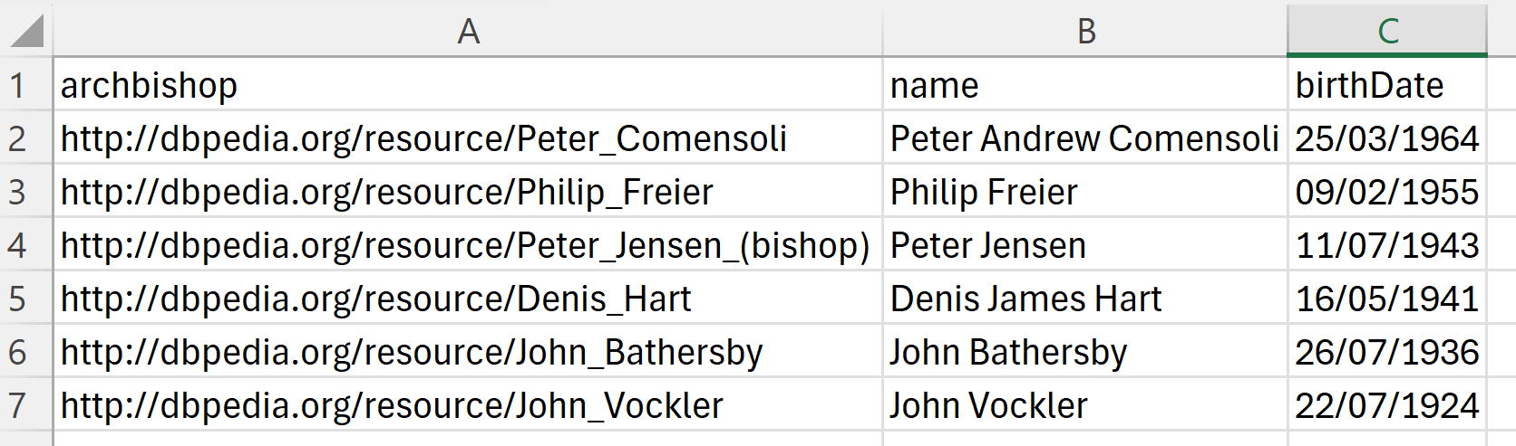

Using RDFLib, we can even represent the Knowledge Graph

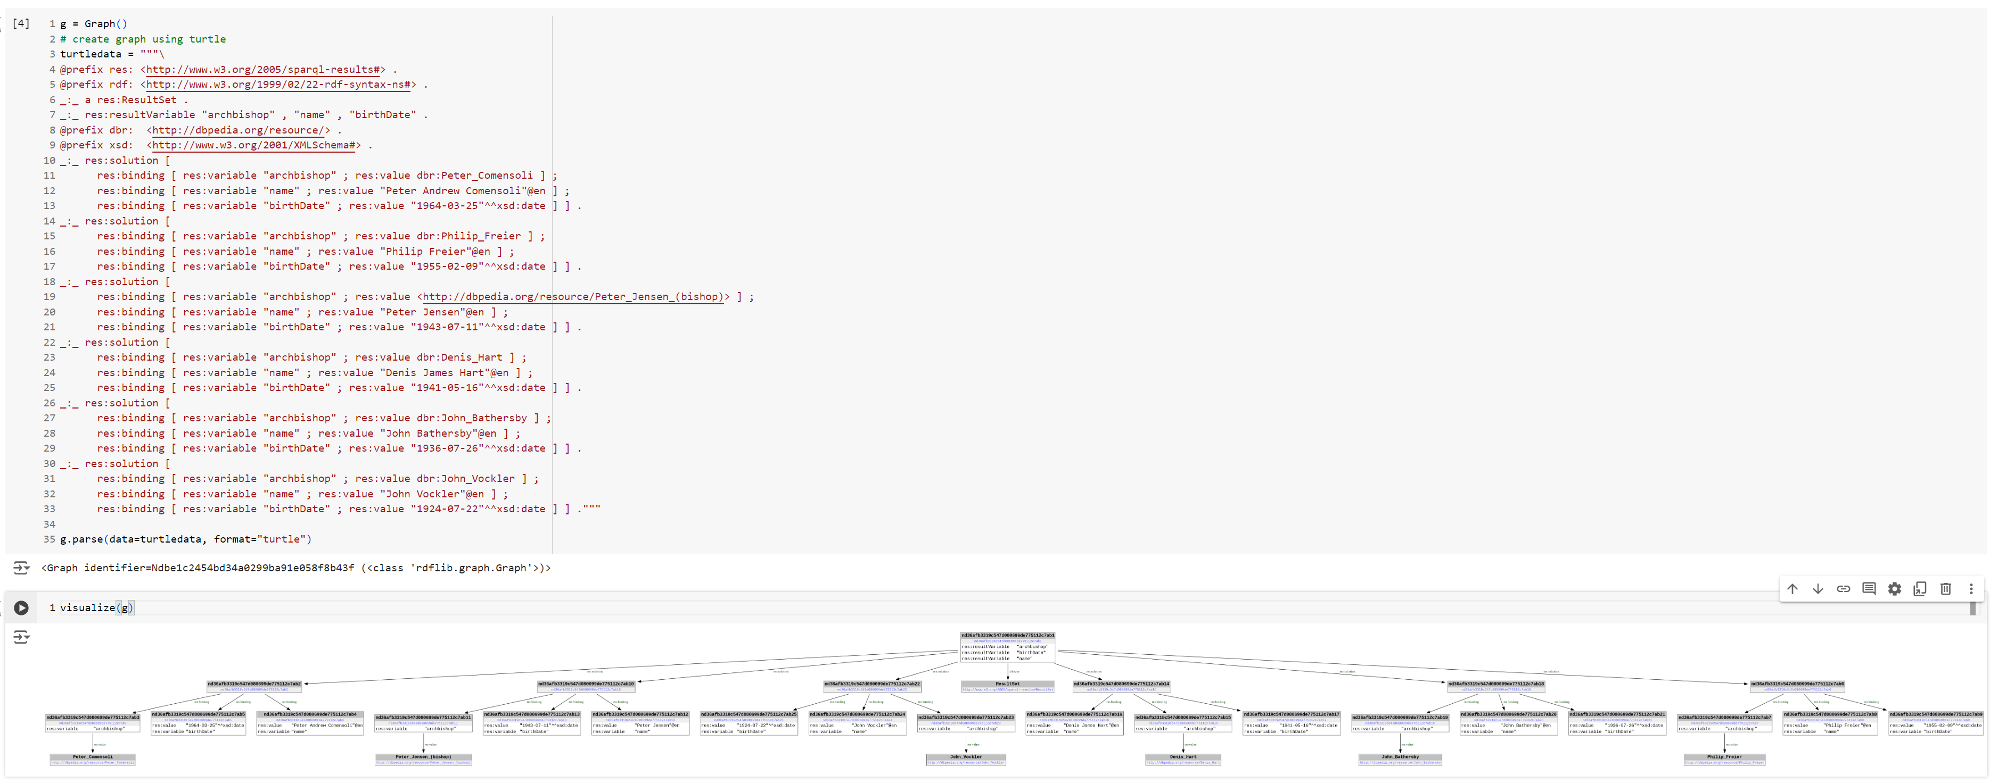

Zooming in, we can see the results of the query, for example, for John Vockler,

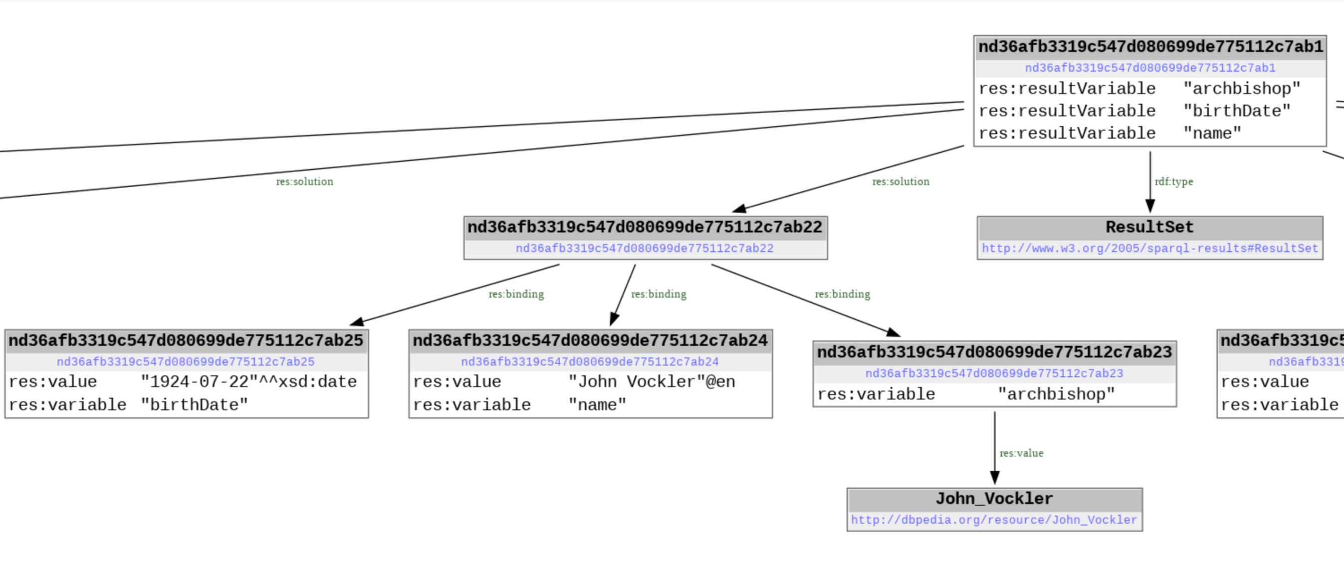

# Conclusion for Task 2

The SPARQL query successfully retrieved detailed information about Australian archbishops, including their names in English and birth dates, sorted from the most modern to the oldest. This task demonstrates the capability of SPARQL and the DBpedia knowledge graph in extracting and organizing specific data, highlighting its utility for historical and biographical research.